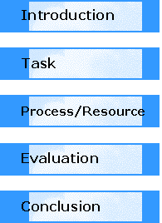
Introduction

As in the Lord of the Flies, your plane has crashed into the ocean. You and your friends have survived and manage to make your way to a seemingly deserted island. You have collected some items from the wreckage of the plane, but in order to survive until a rescue plane or ship arrives, you need to set up your "society".

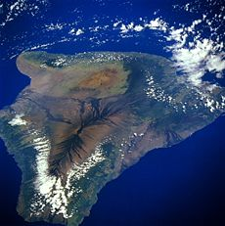 You and your group will need to accomplish the following 3 major tasks:
- You must create a ‘survival manual’ which includes a map of the island, tools needed to build shelters and ways to provide food and water.
- You and your group must decide on a shell that you can use to call the group together. You will make a ‘poster’ of the shell with a drawing and details of its name, how you can use it and its significance.
- You will create a ‘human rights bulletin or poster’ detailing the rules and rights of everyone on the island. You must also note the consequences for anyone who breaks those rules or violates the rights of others.
“This is an island ..... at least I think it’s an island”

Survival Manual
- Your ‘survival manual’ will feature a creative cover, a table of contents, illustrations and text describing the elements of survival. Research (some sites noted below) what equipment you may need. Some items may be found in the wreckage of the plane but you may have to be inventive ad create other ‘tools’. You must also create a map of your island showing where fresh water is, where you would establish your camp and other important or interesting features. How would you be prepared to alert the ‘outside world’ to your presence on the island?

- www.equipped.com
- www.safetystore.com
- http://illustrative-maps.com/
- www.worldatlas.com

Shell Poster
- The shell (Conch or other) is very important to your group. You must design a poster of your chosen shell detailing its scientific name, the background of where it is found, its significance and how it can be used by the group.
- www.seashellworld.com
- www.seashellcity.com
- The symbolic meaning of shells eg: http://ezinearticles.com/?The-Meaning-of-Cowrie-Shells&id=136944

Human Rights Bulletin or Poster
- Develop a bulletin detailing the rules and rights of the inhabitants of the island. Also, you must include the consequences for breaking those rules. Everyone’s rights need to be protected if your new ‘society’ is to be safe. Research on the web to gather information about human rights situations around the world. Be sure your poster demonstrates an awareness of the theme of our study – law and order!

- http://report2009.amnesty.org/press-area/en/node/131

Although students are working in groups, each student is responsible for their own contribution.
The effort you put into your assignment needs to recognise the effort you would need to put into working with the group on the island. If you don’t pull your weight and contribute to the necessary tasks – you will die!

So, individual efforts will be noted during the assignment and marks given accordingly.
It is up to the group decision making process (not just individuals) to decide how the tasks will best be completed successfully.

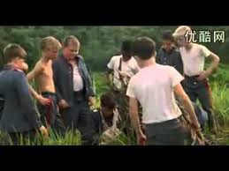

Before you hand your assignment in, ask yourself the following:
- Did you use your classroom time constructively to complete the tasks.
- Is your survival manual clear and complete? Is your map understandable?
- Is the poster of your shell clear and well designed?
- Are your rules, rights and punishments clear and well defined?
Your assessment rubric will be attached to your assignment when it is marked and handed back.

By the end of this project you will have a good understanding of what Ralph, Jack, Piggy and the other boys went through on the island. You will have to ‘organise’ your new society, make rules and find ways to survive. This exercise will give you new insight into what it takes to create a ‘safe’ society.

Our society today has many complex issues and problems to deal with. We must all live together with rules and laws, and we need to abide by these laws! Think about your community – your town or your school. What kind of survival skills will you need to survive in our society today?

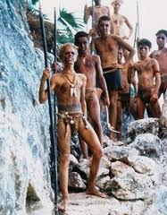

Reference: http://www.longwood.k12.ny.us/lhs/teach/webq/lmasterjohnlord/index.html

