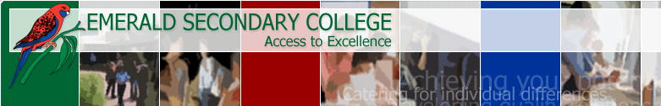

Reading Assessment Tasks (RATS)

Book to Film

Investigate the adaptation of a book to the medium of film.
Some examples include: Harry Potter Series, The Hunger Games, Tomorrow When The War Began, Eragon or Lord of the Rings. Choose one of these, or you may wish to choose your own.

Write a detailed response to the book you have read. Consider:
- The characters — did you find them interesting?
- The scenes you remember most — what made them so memorable?
- The wider issues raised by the book. What were they?
- The author’s style — how successfully did the author create and maintain your interest?

See the film of the book.
Form a detailed response to the following questions:
- What were the main similarities between the book and the film?
- What were the main differences?
- Do you feel that the film set out to recreate the book faithfully, or did it aim to adapt the book?
- Select one or two memorable scenes from the film. What made them particularly memorable? What are the main similarities/differences between these memorable scenes and those which you found memorable in the book?

Use your notes to organise a presentation in which you explain the main differences between the book and film you have studied. Make use of excerpts from the book and scenes from the film.

Assessment checklist

TICK
I have read a book/books to suit the criteria of this task
I have prepared responses to the above questions
I have my note taking sheet ready to hand in with my task sheet
I have completed this task to the best of my ability

All of the work submitted as part of this RAT is my own

Signed: _______________________________________________

Homegroup: _______________________

