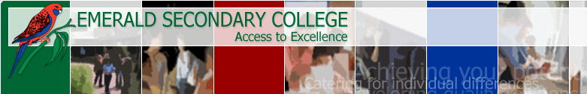

Reading Assessment Tasks (RATS)

Non-fiction book

Read a non-fiction book or magazine article of your choice.
Bibliographic information:
Book title:
Author:
Date of publishing:
Publisher:
Place of publication:

Give a summary of the book or magazine article:
What is the main topic of this
book:
Interesting fact 1:

Interesting fact 2:

This may be completed as a poster, written up or done online.
Assessment checklist

TICK
I have read a book/books to suit the criteria of this task
I have filled in the bibliographical information
I have provided a summary of what I have read
I have completed this task to the best of my ability

All of the work submitted as part of this RAT is my own

Signed: _______________________________________________

Homegroup: _______________________

